# Problem



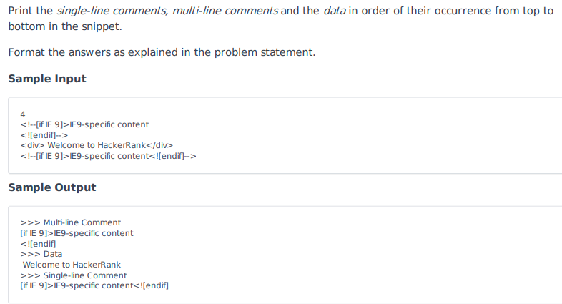

# Solution

from html.parser import HTMLParser

class MyHTMLParser(HTMLParser):

    def handle_comment(self, data):

        number_of_line = len(data.split('\n'))

        if number_of_line>1:

            print('>>> Multi-line Comment')

        else:

            print('>>> Single-line Comment')

        if data.strip():

            print(data)

    def handle_data(self, data):

        if data.strip():

            print(">>> Data")

            print(data)

html = ""

for i in range(int(input())):

    html += input().rstrip()

    html += '\n'

parser = MyHTMLParser()

parser.feed(html)

parser.close()